FOR IRB USE ONLY
IRB ID #: 202011101-1001 APPROVAL DATE: 12/21/20 RELEASED DATE: 12/21/20 EXPIRATION DATE: 12/09/21
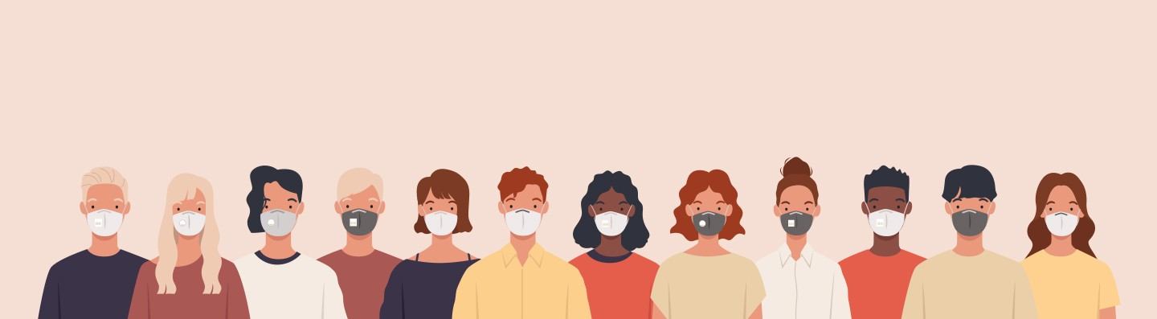

Clinical Trial for COVID-19 Treatment

Researchers at Washington University School of Medicine are testing an
investigational medicine for adults who have symptoms in the early course of Coronavirus treatment.

What is the purpose of this study?
STOP COVID Trial aims to slow the progression of COVID-19 and prevent hospitalization. The study is contactless meaning volunteers can participate without leaving home.

You may be eligible if you:
Are age 18 or older
Tested positive for COVID-19 Are experiencing symptoms

Am I eligible to participate?
You are ineligible if you:
Are experiencing severe symptoms that require hospitalization
Are unable to take the study medication, fluvoxamine

What will happen if I choose to participate?
If you are eligible and choose to participate:
You may be asked to take fluvoxamine or placebo for approximately 15 days and log symptoms two times per day.
Your participation may last approximately 3 months. You will be compensated up to $50 for your time.

How do I learn more and see if I may qualify?
If you have tested COVID-19 positive, Immediately call us at (314) 747-1137,
Email us at stopcovidtrial@wustl.edu, or
Visit us online at http://stopcovidtrial.wustl.edu
(314) 747-1137 | stopcovidtrial@wustl.edu | http://stopcovidtrial.com

