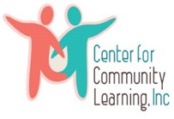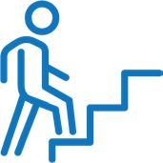

1. Referral source determine eligibility using CSOC Grant Referral Form;
2. Discusses Wraparound, TIP and other services with youth;
3. Complete Referral Form, Consent Form and gather required documentation, including Biopsychosocial and any other clinical documentation available;
4. Email forms to Thriving Mind Children’s System of Care Department at:

[CSOCGrant@thrivingmind.org](mailto:CSOCGrant@thrivingmind.org)

1. Thriving Mind reviews Referral Form, consents, and clinical documentation;
2. If criteria is met, referral is sent to a provider who will engage the youth with services immediately.

**Referral Source:**

**Wraparound Services**

Team based approach used to achieve goals and navigate future challenges

**Center for Community Learning**

Individuals and organizations demonstrate empathy and understanding of and respect for the values, language and experiences of a diverse population



**Transition to Independence Process (TIP) Model**

Youth futures planning and independent living skills

**Children’s System of Care Grant**

**Services and Supports through Thriving Mind | South Florida**

**Thriving Mind South Florida** is a leading a project to help young people and their families during transition into adulthood. This project focuses on youth 14-21 who have emotional and mental health challenges, and who may also have experiences with mental health and/or substance use issues, by supporting their recovery, resiliency, and wellness.

**EVIDENCE-BASED SERVICES**

**FAMILY AND YOUTH ADVOCACY AND SUPPORT**

Our mission is to support the people who help people by providing targeted applied research to empower community organizations to make optimal use of their resources. [www.bsrinstitute.org/](http://www.bsrinstitute.org/)

Federation of Families of Miami-Dade empowers families whose

children and/or youth have or are at risk of behavioral, emotional, mental health, and/or substance abuse challenges through education & advocacy. https://fofmiami.org/

**REFERRAL / ENROLLMENT**

**Supportive Housing**

Finds own apartment in community with housing supports

**Supported Employment & Education**

Finds competitive jobs or back to school goals with one on one supports

**Peer Support**

Linkage to natural supports for mentorship and empowerment